**Modern Algebra RSA Project**

Answers to the quiz: (using the python terminal)

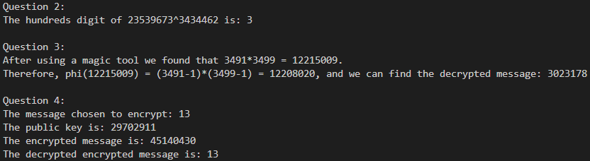

Link to the GitHub directory to review the code:  
<https://github.com/talafek96/RSA-IMPLEMENTATION>